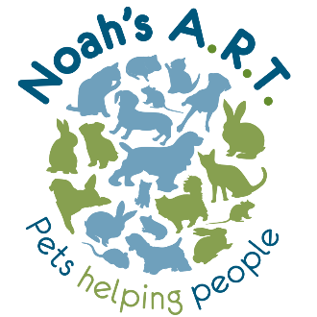

Noah’s ART Community Hub
REFERRAL FORM
Please return completed forms by email to: admin@noahs-art.co.uk or post to Noah’s ART, Ground Floor, 1-9 Borough Arcade, Hyde, SK14 2AA. A member of our team will then be in touch with you/your client as soon as possible to discuss service options, availability and eligibility.
Date of referral:
Does the client consent to this referral? Y / N
1. REFERRER DETAILS (leave blank if self-referring)
Name
Organisation
Phone
Email

2. CLIENT DETAILS

Name
Date of birth
Ethnic group (optional)
Phone
Email
Address
Parent/guardian (if under 18)
Emergency contact name and number (if available)
Are you/the client happy to be contacted directly by Noah’s ART?
Preferred method of contact (please tick) | Phone  Email

3. PREFERRED SERVICES/ACTIVITIES
Please indicate which activities you/your client are most interested in. Leave blank if no preference/not sure
One-to-one pet therapy sessions - £30/session
- Privately funded Y/N
- Funded by EHCP / school / social services etc. Y/N
Volunteering (14+)
Art and community group projects
Funded courses
Dog coffee morning
ALTERNATIVE PROVISION (alternative education for students aged 13-19)

4. REASONS FOR REFERRAL (please describe)

5. RISK FACTORS AND NEEDS

Allergies/phobias
Drugs/alcohol
Mood
Physical health
Mobility
Hearing/vision
Anxiety
Memory problems
Other (please describe)

6. PERSONAL WELLBEING SCALE
We would like to ask you four questions about your feelings on aspects of your life. There are no right or wrong answers. For each of these questions, please give an answer on a scale of 0 to 10, where 0 is “not at all” and 10 is “completely”.
QUESTION | 0-10 SCORE
Overall, how satisfied are you with your life nowadays?

Overall, to what extent do you feel that the things you do in your life are worthwhile?

Overall, how happy did you feel yesterday?

On a scale where 0 is “not at all anxious” and 10 is “completely anxious”, overall, how anxious did you feel yesterday?

7. DATA PROTECTION
The information that you provide on this form and that is obtained from other relevant sources will be used to process your/your child’s referral and support you/your child effectively if you/they become a client. The personal information that you provide will be processed and stored lawfully and in accordance with our Data Protection Policy and the Data Protection Act 2018. We may also use or pass to certain third parties information to prevent or detect crime, to protect public funds or in other ways as permitted by law.
If you/your child decide not to become a client, this form and any other personal data gathered may be held for up to 12 months. In the event that you wish to withdraw your consent to us processing your/your child’s personal data at any point, please contact admin@noahs-art.co.uk.
PLEASE TICK:
I consent to the secure processing and storage of my/my child’s personal data
I understand that I can withdraw my consent at any time, without giving a reason, by contacting admin@noahs-art.co.uk

